Research Progress: Faculty of Computing and Information Technology

Name of Committee: | URC
Date of Meeting: | February 2026
Identify whether the item is Part A (Unreserved) or  Part B (Reserved) Business | Unreserved

Objective:
Here are the FCIT Research objectives:

- To assess research publication progress
Evaluate the faculty's progress in achieving the targeted number of indexed publications and analyze factors influencing the publication rate.

- To evaluate commercialization efforts
Review the status of commercialized products and services, identify challenges, and recommend strategies to enhance commercialization efforts.

- To analyse research and knowledge transfer income
Examine the financial success of research and knowledge transfer initiatives, highlighting key contributors and potential areas for further growth.

- To monitor faculty research participation
Measure faculty engagement in research output, ensuring alignment with institutional research targets and identifying areas for improvement.

- To enhance research investment and strategy
Identify gaps in research investment data collection and suggest measures to optimize research funding, commercialization, and strategic growth.

- To strengthen interdisciplinary collaboration
Assess the extent of cross-departmental and interdisciplinary research activities, identify successful collaborative models, and recommend initiatives to encourage broader academic partnerships and innovation.

Summary:
Table 1: Achievement of Institutional Research Corporate Targets

KPI | Target* | Achieved** | Comments
Number of Indexed Publications | 60 | 41 | The academic output includes 41 Scopus-indexed journal papers, 4 non-indexed journal papers and 3 conference papers. Two papers were co-authored with students. There is involvement of one research fellow and one adjunct.
Number of Commercialized Products and Services | 2,500 | 0 | FCIT is planning to commercialize the projects for the final year and the research projects
Research and Knowledge Transfer Income | 120,000 | 126,245 | Ongoing 78,850 OMR (4 RG and 16 URG), and 1 EJAAD project accepted amounted to 8300 OMR in FCIT.  Furthermore, research proposals have recently been approved, including 2 RG, 3 GRG, and 9 URG, with a total budget of 47,395 OMR.  The total value of currently funded and approved research projects amounts to 126,245 OMR. This includes the ongoing funded projects, the project accepted under EJAAD, as well as the recently approved research grants within the FCIT.
Investment in Research and Knowledge Transfer (fill in AB4) | - | -
Ratio of Academic Staff Generating Research Output*** | 39 | 64% | Out of 39 faculty members, 22 existing staff and 3 newly joined staff produced at least one Scopus-indexed journal article during the current academic year. A total of 41 Scopus-indexed publications were recorded.

FCIT Research Corporate Targets

The FCIT has made notable progress toward its research corporate targets. While publication and research income goals are on track or have been exceeded, commercialization efforts still require further attention. Out of a total of 39 faculty members, 23 staff (22 existing and 1 newly joined) contributed to research publications, resulting in 40 Scopus-indexed articles. This reflects strong faculty engagement in research. Moving forward, a strategic focus on commercializing research projects and systematically documenting research investments will be essential for sustained success. Overall, the data demonstrates positive trends in research output, financial performance, and faculty research participation.
- Number of Indexed Publications
- Target: 60
- Achieved: 40
The FCIT has shown significant progress in research publications in 2025, indicating steady growth toward achieving its publication targets.
2. Number of Commercialized Products and Services
- Target: 2,500
- Achieved: 0
Currently, no products or services have been commercialized. However, the FCIT has initiated plans to commercialize final-year and research projects. Further efforts are required to align commercialization strategies with institutional goals.

3. Research and Knowledge Transfer Income

- Target: 120,000
- Achieved: 126,245
FCIT demonstrated strong growth in research and knowledge transfer income across the academic years 2025 and 2026.
In 2025, the college generated 78,850 OMR, securing 4 Research Grants (RG), 16 Undergraduate Research Grants (URG), and 1 EJAAD project, with an additional 20,500 OMR recently approved. In 2026, FCIT secured a further 47,395 OMR, comprising 2 Research Grants (RG), 3 Graduate Research Grants (GRG), and 9 Undergraduate Research Grants (URG).
Across both years, FCIT successfully obtained 6 RG, 25 URG, 3 GRG, and 1 EJAAD project, with a combined total funding of 126,245 OMR, reflecting sustained growth, diversified funding streams, and strong alignment with strategic research and innovation priorities.

4. Ratio of Academic Staff Generating Research Output
- Target: 39
- Achieved: 64%
Out of 39 faculty members, 22 existing staff and 3 newly joined staff produced at least one Scopus-indexed journal article during the current academic year. A total of 41 Scopus-indexed publications were recorded.
Recommendation:
AB
Name of Author: | Dr. Taher M. Ghazal
Title of Author: | Assistant Professor
Staff Endorsing the Paper: | Professor Kayed, The Dean of the FCIT

Table 2: Quarterly monitoring of research progress
Sr. No | Research and Innovation highlights | Last Report to AB** | Current report (Accumulated)
1 | Increased number of Adjunct Professors | 11 | 9
2 | number of Scopus articles | 36 | 5
3 | The proportion of faculty members participating in research decreased to 64% due to the addition of newly joined faculty members who have not yet contributed to research output. | 22 | 25
4 | Total external income has reached OMR 126,245 (includes block-funding, consultancies, and any other external Knowledge Transfer income) | 20500 | 78,850 Ongoing  And 47,395 recently accepted for 2 RG AND 3 GRG AND 9 URG)
5 | Research Collaborative partnerships with industry and universities | - | -
6 | Non-Indexed Publications | - | 4 Journal papers  2 Conference Papers
 | Keynote presentation at conferences | - | 2 faculty invited as keynote speakers.  1 faculty served as Conference Chair for two international conferences, including an IEEE conference and an Elsevier Scopus-indexed (Q2) conference.
 | Invited presentations at the conferences | - | 1 faculty presented at 2 international conferences
 | Regular (registration paid) presentation at the conferences | - | -
7 | Number of publications with students | - | 2
8 | Publications by Adjunct Faculty | 19 | 9 Adjunct Faculty produce 19 papers for 2025
9 | Students’ Involvement in Research | 143 Undergraduate + 4 PhD candidates + 10 Master | %100
10 | Editorial Appointments | - | 2 faculty serving on the editorial board of highly ranked journals.
11 | Incubation and Technology Transfer achievements | - | -
12 | Projects or publications contributing to SDGs | 45 | N/A
*Preferable to provide details in appendix (left to the discretion of the Dean)
** for AB1, leave column empty
Table 3: Achievement of Targets (Annual)

Sr. No | Faculty Research Plan |  | Measured in | Target in 2025-2026 (From 1 September 2025) | Achieved
1 | Total Research and Knowledge Transfer Income* |  | OMR | 60,000 | In process
2 | Number of external grant applications |  | Nos. | 9 | 2 submitted
3 | Number of internal funding applications |  | Nos. | 3 | 1 submitted
4 | Number of Consultancies granted (EJAAD, etc.) |  | Nos. | 1 | Ongoing 1
5 | Total Block Funding income |  | OMR | 120,000 | 126,245
6 | Number of ongoing Internal grant projects |  | Nos. | 2 | 1
7 | Number of Block Funding Applications | Research Grant (RG) | Nos. | 3 | 1 submitted
 |  | Graduate Research Grant (GRG) | Nos. | 3 | -
 |  | Undergraduate Research Grant (URG) | Nos. | 3 | 2 submitted
8 | Number of commercialized products and services |  | Nos. | 1 | The FCIT is planning and progressing to act to enhance the value of commercialized products and services by fostering innovation, optimizing market strategies, and ensuring sustainable growth.
9 | Value of commercialized products and services |  | OMR | 2.500 | On the progress
10 | Number of research publications in indexed journals (Scopus, WoS) |  | Nos. | 60 | 41
11 | Number of students involved in research |  | Nos. | Nos | 143 Undergraduate + 10 Master + 4 PhD candidates
12 | Joint publications with students |  |  | - | 2
13 | Number of other publications (e.g., books, chapters, conferences, reviews, etc.) |  | Nos. | - | 3
14 | Publications by Adjunct Professors |  | Nos. | - | 24
15 | Publications by Research Fellows |  | Nos, | 3 | 3
16 | Number of R&I awards and recognitions [Global Profile and Stature] |  | Nos. | Faculty self-imposed target | 2 Faculty of top 2% scientists

Table 4: Joint academic – student publications

Authors (highlight student) | Title | Journal name | Volume and Issue | DOI
Reem Al Maawali | Improving the learning skills of autistic students using social robotics technologies | Journal of Infrastructure, Policy and Development | 8/16 | https://systems.enpress-publisher.com/index.php/jipd/article/viewFile/7974/5043
Ahmad Albrieki | TeacherEval: An AHP-TOPSIS system for data-driven teacher evaluation in the Sultanate of Oman | IJAAS  International Journal of  ADVANCED AND APPLIED SCIENCES | Volume 12, Issue 12 (December 2025), Pages: 192-206 | https://www.science-gate.com/IJAAS/2025/V12I12/1021833ijaas202512017.html
Salem Salameh | Adoption of Cloud-Based Smart Grids: Insights from Oman's Electricity Sector | Fusion: Practice and Applications - ASPG |  | https://doi.org/10.54216/FPA.200214

Table 5: Publications by Adjunct Professors

Authors (highlight student) | Title | Journal name | Volume and Issue | DOI
Ali H. A. Alwaeli | Techno-economic optimization of solar adsorption… | Thermal Science and Engineering Progress | — | 10.1016/j.tsep.2025.103771
Ali H. A. Alwaeli | Performance of a photovoltaic-thermal solar collector… | Solar Energy | — | 10.1016/j.solener.2025.113541
Ali H. A. Alwaeli | A review of photovoltaic/thermal (PV/T)… | Global Energy Interconnection | — | 10.1016/j.gloei.2025.03.001
Ali H. A. Alwaeli | Solar photovoltaic/thermal systems applications… | Environment, Development and Sustainability | — | 10.1007/s10668-023-04152-6
Ali H. A. Alwaeli | Optimal nanofluid selection for PV/T systems | Case Studies in Thermal Engineering | — | 10.1016/j.csite.2024.105610
Ali H. A. Alwaeli | Performance evaluation of PV/T systems | Energy Sources, Part A | — | 10.1080/15567036.2025.2590598
Mohammad Reza Chalak Qazani | Optimising the power regeneration and chemical process… | Renewable Energy | — | 10.1016/j.renene.2025.124188
Mohammad Reza Chalak Qazani | Mechanical properties prediction of bi-metal structures | Engineering Applications of Artificial Intelligence | — | 10.1016/j.engappai.2025.112560
Mohammad Reza Chalak Qazani | Cell-to-cell communication: from physical calling… | Discover Nano | — | 10.1186/s11671-025-04363-y
Mohammad Reza Chalak Qazani | SMOTE-ENN resampling with Bayesian optimisation | Applied Soft Computing | — | 10.1016/j.asoc.2025.113467
Mohammad Reza Chalak Qazani | Genetic modeling for enhancing machining performance | Arabian Journal for Science and Engineering | — | 10.1007/s13369-024-09330-w
Mohammad Reza Chalak Qazani | A novel Layer-2 blockchain framework | Computer Networks | — | 10.1016/j.comnet.2025.111148
Mohd Shafry Mohd Rahim | A dynamic image retrieval framework | Journal of Theoretical and Applied Information Technology | — | Scopus link
Mohd Shafry Mohd Rahim | Crack background removal for concrete inspection | IFMBE Proceedings | — | 10.1007/978-3-031-97578-3_75
Mohd Shafry Mohd Rahim | Imbalanced dataset evaluation for X-ray baggage scanning | IFMBE Proceedings | — | 10.1007/978-3-031-97578-3_53
Durgesh Srivastava | Comparative analysis of multitask neural networks | Engineering Proceedings | — | 10.3390/engproc2025114019
Asyraf Afthanorhan | Solar-based electric vehicle charging framework | International Journal of Mathematical, Engineering & Management Sciences | — | 10.33889/IJMEMS.2025.10.6.098
Asyraf Afthanorhan | Optimal power flow using novel optimization | Expert Systems with Applications | — | 10.1016/j.eswa.2025.128163
Mohammad Shafi | Deep learning-driven radiographic classification | Biomedical Signal Processing and Control | — | 10.1016/j.bspc.2025.108888
Mohammad Shafi | Zirkus Empathico 2.0 serious game | Multimedia Tools and Applications | — | 10.1007/s11042-025-20826-x
Mohammad Shafi | ECG interpretation expertise assessment | IEEE Access | — | 10.1109/ACCESS.2025.3528253
Dilovan Asaad Zebari | Improving SpikeProp’s training efficiency | International Journal of Computational Intelligence Systems | — | 10.1007/s44196-025-00961-x
Dilovan Asaad Zebari | Kidney disease segmentation and classification | Bioengineering | — | 10.3390/bioengineering12040350
Ahmad Afshar | Restoring structural controllability of interdependent networks | Sustainable Energy, Grids and Networks | — | 10.1016/j.segan.2025.101954

Table 6: Consultancy and knowledge transfer projects and income (Commercialized products and services)

Name of project | Start date | End date | Client or sponsor | Amount

Table 7: Involvement of Academic Staff in External Supervision and Examination (During Period Of Employment At Sohar University)
S/N | Academic | Year | Degree (Masters or PhD) | University | Title | Student
1 | Falah Hamode (Main Examiner) | 2025 | MSc | Sohar University | Using Furhart Robot to Improve Face Recognition | Reem Al Maawali
2 | Muhammad Zeeshan (Main Examiner) | 2025 | MSc | Sohar University | An Efficient Reinforcement Learning–Based Intrusion Detection System for MQTT-Based IoT Networks | Sheikha Said Rashid Al Mamari
3 | Muhammad Zeeshan (Co-Examiner) | 2025 | MSc | NUST University, Islamabad | AI-Based Credit Scoring Framework Using Ensemble Models with FICO Standard | Muzamil Khan
4 | Muhammad Zeeshan (Co-Examiner) | 2025 | MSc | NUST University, Islamabad | Detection and Classification of Realistic and Generated URL-Based Synthetic Phishing Attacks Using a Transformer-Based Hybrid Model | Haleema Sadia
5 | Muhammad Zeeshan (Co-Examiner) | 2025 | MSc | NUST University, Islamabad | Detection of Malicious Data Hidden in Plain Sight: A Framework for Analyzing DNS Tunneling Attacks | Fatima Tu Zahra
6 | Muhammad Zeeshan (Co-Examiner) | 2025 | MSc | NUST University, Islamabad | Encrypted Traffic Classification for Network Intelligence and Security | Zuha Khalid
7 | Muhammad Zeeshan (Co-Examiner) | 2025 | MSc | NUST University, Islamabad | Feature-Driven Segregation of DoS and DDoS Attacks Using Machine Learning | Asfia Javed
8 | Muhammad Zeeshan (Main Examiner) | 2025 | MSc | NUST University, Islamabad | Detection of ARP-Based Man-in-the-Middle Attacks Using Hybrid Techniques | Noor Fatima

Table 8. Research grants RG/GRG/URG accepted Recently for 2024-2025

No | Title | Approved Funds  (OMR) | Staff Name | Role | Type
1 | AI-Driven Solution for Enhancing English Language Proficiency: Revolutionizing Teaching and Learning for Omani Students | 17,050 | Dr. Marwan Alshare | PI | RG
2 | The Dusting method for sustainable Smart Cities for OMAN Vision 2040 | 16,000 | Dr.Falah Hamode | PI | RG
3 | Integrate Virtual Reality into the educational setting of Omani universities to enhance students learning outcomes: A case study of Sohar university | 15,000 | Dr. Khaled Abuhmaidan | PI | RG
4 | Combating harm: an AI based approach for cyberbullying detection in Arabic Language | 6,800 | Dr. Sanad Al Maskari | PI | RG
5 | AI-Powered Facial recognition for behavioral analysis: Optimizing Omani Student’s learning intention. | 15,00 | Saiyadil Saif Uddin | PI | URG
6 | Unlocking Potential: Predicting Career Paths and Creativity in Students with Special Needs Using Artificial Intelligence | 1,500 | Majd Al Hamedi | PI | URG
7 | TouchAI EduGuide: An Integrated AI-Driven Touchscreen System with Interactive Animator for Student Advisory and Data Analytics in Higher Education | 1,500 | Sree Mughi Chandrasekar | PI | URG
8 | Advanced Vocational Algorithmics: Architecting a Multi-Platform AI-Driven System for Precision Guidance in Omani Secondary School Education | 1,500 | Samiya Mohammed | PI | URG
9 | Investigating the use of AI Robotics in the classroom. | 1,500 | Rawan AL Zaabi | PI | URG
10 | Breaking Barriers: Empowering Communication for Omani Individuals with Hearing Disabilities for Full Engagement in Community and Job Market | 1,500 | Fatma Harib | PI | URG
11 | Leveraging Holographic Technology for Down Syndrome Therapeutic Intervention | 1,500 | Reem Al Moqbali | PI | URG
12 | Smart Vision: Empowering Oman's Visually Impaired and Blind with Innovative Glasses | 1,500 | Nahiya AL Hamdani, | PI | URG
13 | Arabic Fake Messages Detection using an AI Approach | 1,500 | Marwan AL Saidi | PI | URG
14 | Exploring the use of gamification in education in the era of AI | 1,500 | Fatin AL Shammakhi | PI | URG
15 | Smart Shopping Cart and Bill Management using Mobile App and IoT Technology. | 1,500 | Hiba Al Mamari | PI | URG
16 | Enhancing Interactive Learning with Hologram Technology: A Novel Approach in Education in Oman | 1,500 | Tasnim Al Ghafri | PI | URG
17 | A Multi-Agent System Utilizing AI Techniques for Streamlined Job Matching and Company Recruitment in Oman. | 1,500 | Fatma Al Jabri | PI | URG
18 | Crowed based solution for waste monitoring. | 1,500 | Ahoud AL Saidi | PI | URG
19 | Enhancing Tourism Experience in Oman through an AI-Driven Smart Tourism Agent System: A Service-Oriented Architecture Approach | 1,500 | Omar Al Shehhi | PI | URG
20 | Developing an Enterprise Resource Planning software for Omani Businesses: An internet-based Coding Approach | 1,500 | Rahma AL Zeidi | PI | URG
21 | Camel Crossing Prevention Industry Challenge | 8300 | Dr. Marwan | PI | Ejaad
Total |  | 78,850 |  |  | Mentor
No | Title | Approved Funds  (OMR) | Staff Name | Role | Type

22 | An AI-Based Digital Management System for Document Archiving and Documentation: A Case Study of Al-Owtabi Center | 11,700 | Dr. Mahmood Said Nasser Al Bahri | PI | RG
23 | Advancing Ethical AI Integration in Oman: A Middleware Framework for Evaluating and Measuring Ethical Principles in Artificial Intelligence Systems | 13,220 | Dr. Abualkishik, Abdallah | PI | RG
24 | AI-Powered Robotic Task Management and Assistance System for Organizational Efficiency | 3,000 | Reem Rashid Mohammed Al. Maawali | PI | GRG
25 | Harnessing AI for understanding student data : a practical approach for higher education institutes in Oman | 3,000 | Budour Ahmed. Al Farsi | PI | GRG
26 | Exploring the use of AI and immersive technologies in education in the sultanate of Oman: opportunities and challenges. | 3,000 | Kholood Mohammed Abdullah Al farsi | PI | GRG
27 | Law-Bot: A comprehensive Analysis of AI Models: Standards, Performance, and Ethical Considerations | 1,500 | AL-WALEED KHALID SULAIMAN AL ISAII | PI | URG
28 | Smart IoT-Based Non-Invasive Glucose Monitoring and Analytics Management System-based Mobile Application. | 1,500 | Ahmed hamdan al maqbali | PI | URG
29 | AI and IoT-Based Solution for Early Detection and Control of Red Palm Weevil | 1,500 | Ali Al-Ajmi, | PI | URG
30 | Enhancing Early Learning in Omani Schools through Hand Drawn Shape Recognition using Gemini and Augmented Reality (AR) | 1,500 | MOHAMMED IBRAHIM MOHAMMED AL-NIYADI (ID. 080793) | PI | URG
31 | The Oman Tourist Mate: AI-Powered Personalized Tour Planning Application | 1,500 | Shama Ahmed Abdullah AL-RISI | PI | URG
32 | Smart Academic Transfers: AI-Driven Course Equivalence for Universities | 1500 | MAZNA SAIF ABDULLAH ALHASANI | PI | URG
33 | Smart Soil Sense: AI-Driven Soil Analysis for Sustainable Agriculture in Oman | 1475 | Razan Mahmoud younis | PI | URG
34 | AI-Based System for Automated Video Content Analysis, Classification, and Behavioral Impact Assessment | 1,500 | SAID MOHAMMED ALI AL MAHRIZI, TUQA (222938) | PI | URG
35 | Artificial Intelligence-Based Rainfall Forecasting and Its Impacts in Oman | 1500 | AHMED ZAKARIYA AL-FARSI, HALIMA 243802 | PI | URG
Total |  | 47,395 | from 1 march 2026
Total Grant |  | 126,245

Table 09. Published papers in Scopus ranked journals (September 2025)

SU Authors | Title | Scopus Q | Month | Year | Journal | DOI
Saqib Qamar | ScaleFusionNet: transformer-guided multi-scale feature fusion for skin lesion segmentation | Q1 | October | 2025 | Scientific Reports | 10.1038/s41598-025-17300-x
Saqib Qamar | UNet with self-adaptive Mamba-like attention and causal-resonance learning for medical image segmentation | Q1 | December | 2025 | Scientific Reports | 10.1038/s41598-025-28885-8
Rashid Moamber Ahmad | Machine learning-based cotton yield forecasting under climate change for precision agriculture | Q1 | December | 2025 | Smart Agricultural Technology | 10.1016/j.atech.2025.101117
Rashid Moamber Ahmad | Cross-cluster precision-guided knowledge fusion for fair and personalized federated learning | Q1 | October | 2025 | Alexandria Engineering Journal | https://www.sciencedirect.com/science/article/pii/S1110016825006842
Rashid Moamber Ahmad | Machine Learning-Driven Insights Into Lighting Use in Industrial Buildings | Q4 | October | 2025 | Lecture Notes in Mechanical Engineering ((LNME)) | https://link.springer.com/chapter/10.1007/978-981-96-9740-3_14
Falah Hamode | Improving SpikeProp’s Training Efficiency in Spiking Neural Networks for Large Language Models Through Innovative Weight Initialization | Q2 | November | 2025 | International Journal of Computational Intelligence Systems | https://doi.org/10.1007/s44196-025-00961-x
Falah Hamode | Bayesian-Optimized Hybrid Machine Learning Model for Coastal Wind Gust Prediction in a Marine-Influenced Atmospheric Boundary Layer | Q2 | December | 2025 | Journal of Atmospheric and Solar-Terrestrial Physics | https://doi.org/10.1016/j.jastp.2025.106629
Syed Muhammad Zubair Rehman Gillani | Enhancing Smart Outdoor Object Navigation for the Visually Impaired via YOLOv10 with Neighbor Coordinates and C2FCIB Attention Mechanism | Q1 | October | 2025 | IEEE Access | 10.1109/ACCESS.2025.3612482
Mohammed Muthanna | A ResNet-50–UNet Hybrid with Whale Optimization Algorithm for Accurate Liver Tumor Segmentation | Q1 | November | 2025 | Diagnostics | https://doi.org/10.3390/diagnostics15232975
Mohammed Muthanna | An Integrated Architecture for Colorectal Polyp Segmentation: The µ-Net Framework with Explainable AI | Q1 | November | 2025 | Diagnostics | https://doi.org/10.3390/diagnostics15222890
Muhammad Zakarya | Adaptive Clustering in FANETs: A Fuzzy Logic Approach for Energy Efficiency and Network Stability | Q1 | October | 2025 | Telecommunication Systems, Springer | 10.1007/s11235-025-01356-1
Abdallah Mohammad Mustafa Abualkishik | TeacherEval: An AHP-TOPSIS system for data-driven teacher evaluation in the Sultanate of Oman | Q3 | December | 2025 | International Journal of Advanced and Applied Sciences | 10.21833/ijaas.2025.12.017
Abdallah Mohammad Mustafa Abualkishik | Adoption of Cloud-Based Smart Grids: Insights from Oman's Electricity Sector | Q3 | December | 2025 | Fusion: Practice and Applications | https://doi.org/10.54216/FPA.200214
Abdallah Mohammad Mustafa Abualkishik | Design and Development of SLRAI Wizards as an AI-Powered Solution to Enhance Learning Experiences in the Research Process | N/A | November | 2025 | Jurnal Kejuruteraan ( ISSN:0128-0198) | https://doi.org/10.17576/jkukm-2025-37(8)-23
Taher Mhd Zakaria Ghazal | A prognosis-centric evaluation model for wearable sensor inputs in digital health intelligence | Q1 | December | 2025 | Biomedical Signal Processing and Control | 10.1016/j.bspc.2025.108740
Taher Mhd Zakaria Ghazal | Enhancing Cloud Resource Utilization Through Synthesizing Intensive Workflow Tasks | Q2 | December | 2025 | Journal of Wireless Mobile Networks, Ubiquitous Computing, and Dependable Applications | 10.58346/JOWUA.2025.I4.030
Taher Mhd Zakaria Ghazal | Lightweight signcryption scheme for Securing wearable sensor observed health data sharing in internet of medical things paradigm | Q1 | December | 2025 | Scientific Reports | 10.1038/s41598-025-24687-0
Taher Mhd Zakaria Ghazal | Machine learning-based real-time outage fault detection for distribution networks in smart grid | Q1 | December | 2025 | Energy Reports | 10.1016/j.egyr.2025.10.045
Taher Mhd Zakaria Ghazal | Deep learning for sports motion recognition with a high-precision framework for performance enhancement | Q1 | December | 2025 | Scientific Reports | 10.1038/s41598-025-22701-z
Taher Mhd Zakaria Ghazal | Enhancing artistic style classification through a novel ArtFusionNet framework | Q1 | December | 2025 | Scientific Reports | 10.1038/s41598-025-20087-6
Taher Mhd Zakaria Ghazal | Privacy-Preserving Transformer-Based Meta-Learning Algorithm for Zero-Day Intrusion Detection in IoT-Enabled Smart Grids | Q2 | December | 2025 | Journal of Internet Services and Information Security | 10.58346/JISIS.2025.I4.020
Taher Mhd Zakaria Ghazal | Federated Deep Graph Neural Network Algorithm for Real-Time Intrusion Detection in Heterogeneous IoT Systems | Q2 | December | 2025 | Journal of Internet Services and Information Security | 10.58346/JISIS.2025.I4.021
Taher Mhd Zakaria Ghazal | Interpretable machine learning framework for predicting Urban air quality | Q1 | December | 2025 | PLOS ONE | 10.1371/journal.pone.0336241
Taher Mhd Zakaria Ghazal | Hierarchical Edge-Cloud Collaborative AI Algorithm for Energy-Efficient lot Management in Ubiquitous Computing Environments | Q2 | December | 2025 | Journal of Wireless Mobile Networks, Ubiquitous Computing, and Dependable Applications | 10.58346/JOWUA.2025.I3.035
Taher Mhd Zakaria Ghazal | Adaptive Neuro-Fuzzy Congestion Control Algorithm for Real-Time Multimedia Networking in Cloud-Based E-Learning Platforms | Q2 | December | 2025 | Journal of Wireless Mobile Networks, Ubiquitous Computing, and Dependable Applications | 10.58346/JOWUA.2025.I3.027
Taher Mhd Zakaria Ghazal | Enhanced eDNA Recovery from Microplastic-Polluted Freshwater Systems Using Surfactant-Assisted Bead-Beating with Enzymatic Digestion | Q1 | December | 2025 | Natural and Engineering Sciences | 10.28978/nesciences.1811139
Taher Mhd Zakaria Ghazal | Federated Learning for Intelligent Sensing and Navigation Technologies for 6G Communications | Q1 | December | 2025 | Journal of Sensors | 10.1155/js/3746147
Taher Mhd Zakaria Ghazal | Knowledge Learning for Securing Workflow Scheduling Algorithm in Mobile Edge Computing | Q1 | December | 2025 | Mobile Networks and Applications | 10.1007/s11036-025-02465-6
Furqan Alam | Benchmarking Robust AI for Microrobot Detection with Ultrasound Imaging | Q1 | December | 2025 | Actuators | https://doi.org/10.3390/act15010016
Eimad Eldin Abusham | Sustainable Development and Green Technologies as a New Dimension of Foreign Policy Co-operation: A Comparative Study of Kazakhstan and the Gulf State | Q1 | September | 2025 | World Journal of Entrepreneurship, Management and Sustainable Development (WJEMSD) | https://wasdlibrary.org/download/wjemsd-v21-n4-2025-sd-green-technologies-foreign-policy-co-operation-kazakhstan-gulf-states/
Eimad Eldin Abusham | Machine learning models predictive performance of Asian economies’ green technological progress | Q1 | December | 2025 | Sustainable Futures | https://doi.org/10.1016/j.sftr.2025.101323
Mahmood Said Nasser Al Bahri | Architecting The Intelligent Classroom: A Systematic Review and Framework for IoT-Enabled Learning Environments | Q4 | October | 2025 | International Journal of Basic and Applied Sciences | https://doi.org/10.14419/2d4wmf90
Taher Mhd Zakaria Ghazal | Early diagnosis of alzheimer’s disease using PET imaging and deep learning with comparative data | Q1 | January | 2026 | Scientific Reports | 10.1038/s41598-025-28866-x
Taher Mhd Zakaria Ghazal | Lightweight Homomorphic Encryption Algorithm for Secure Cloud Storage in Bibliographic Control Systems | Q1 | January | 2026 | Indian Journal of Information Sources and Services | 10.51983/ijiss-2026.16.1.13
Belal Mohammad Ahmad Al Ifan | CLOUD-BASED SECURITY APPROACHES FOR SAFEGUARDING IOT ENVIRONMENTS AND DEVICES | Q4 | January | 2026 | Journal of Mechanics of Continua and Mathematical Sciences | https://doi.org/10.26782/jmcms.2026.01.00001
Belal Mohammad Ahmad Al Ifan | ENHANCING INTEROPERABILITY AND STANDARDIZATION IN IOT AND CLOUD INTEGRATION | Q4 | January | 2026 | Journal of Mechanics of Continua and Mathematical Sciences | https://doi.org/10.26782/jmcms.2026.01.00005
Hesham Ali Ibrahim Sakr | SBFL-GAN: secure blockchain empowered federated learning and GAN model for providing preserving of IoMT | Q1 | January | 2026 | Neural Computing and Applications | https://link.springer.com/article/10.1007/s00521-025-11758-6

Table 10: SDGs Alignment with research and consultancies (Annual)

S# | Description | Title | SDGs | Indicators of SDG
1 | Research Paper | Leadership Strategies in Addressing Out-of-School Children: A Comparative Study of Heads of Government and Public–Private-Managed Schools in Sindh, Pakistan | SDG 4 | 4.1.1.  4.5.1  4.a.1
 |  |  | SDG 10 | 10.2.1
 |  |  | SDG 17 | 17.17.1
2 | Keynote talk | Pedagogy for Scientific Thinking to Create Sustainable Learning Environment: A move towards creating resilient education systems for the 21st century” at the 2nd Quality Day organized by the Oman Association for Quality in Higher Education (OAQHE) | SDG 4 | 4.7.1.
 |  |  | SDG 9 | 9.5.1
 |  |  | SDG 12 | 12.8.1

Table 11. STRATEGIC GOAL: CREATE AND INNOVATE

Strategic Objectives | Strategic Initiatives | KPI | Target
6.1 To Develop in areas of existing research strength | Establish research groups focusing on FCIT niche areas to enhance collaborative proposals and publications | Number of research groups established | 5 research groups | RG Rep-RF
 | Develop collaborative research proposals in identified niche areas | Number of proposals developed | 4 proposals | FCIT Research Committee
 | Establish national and international research partnerships aligned with Oman Vision 2040 and SDGs | Number of active MoUs/MoAs | 2 active agreements | Dean Assistant Dean of FCIT
6.2 To Increase Research Capacity and Capability | Appoint research mentors to enhance faculty research skills | Number of mentors appointed | 6 mentors | Dean Assistant Dean of FCIT
6.3 To Increase Research  Experience to FYP students | Conduct national/international research engagement sessions | Number of research talks | 5 sessions | R&D Representative
6.4 To Integrate support for enterprise, innovation, and knowledge transfer | Implement FCIT Research Month activities | Number of interventions | 3 activities | R&D Representative
 | Conduct Level 4 research writing and publication workshop | Number of workshops | 1 workshop | R&D Representative

RESEARCH CHALLENGES:

The main challenges impacting FCIT research performance include:

- Predominantly individual-based research rather than structured team-driven grant applications.
- Limited interdisciplinary and cross-faculty research engagement.
- Insufficient industry-linked research problems and collaborations.
- Limited clarity in interpreting major national and international research calls.
- Need to further strengthen research motivation and sustainable research culture.
- High teaching and administrative workload limiting sustained faculty engagement in research activities.
WAY FORWARD:
To address the identified challenges and strengthen research sustainability, FCIT will focus on the following actions:
- Establish structured research groups aligned with faculty niche areas to promote collaborative research.
- Enhance interdisciplinary and cross-faculty research engagement.
- Strengthen industry collaboration through problem-driven and applied research initiatives.
- Improve coordination and guidance for national and international research grant calls.
- Enhance professional development through targeted research workshops and capacity-building programs.
- Strengthen research mentoring to support early-career researchers.
- Optimize faculty workload allocation to enable balanced engagement in teaching, research, and innovation activities.
- Promote a supportive and sustainable research culture across the faculty.
- Establish an Artificial Intelligence lab to run and classify datasets and analyse the outcome of simulations for various research areas.
- Also include undergraduate students in research and concentrate on final-year project enhancements.
- Recruit new researchers with a strong research profile for FCIT.

_________________________________________________
Top research achievement

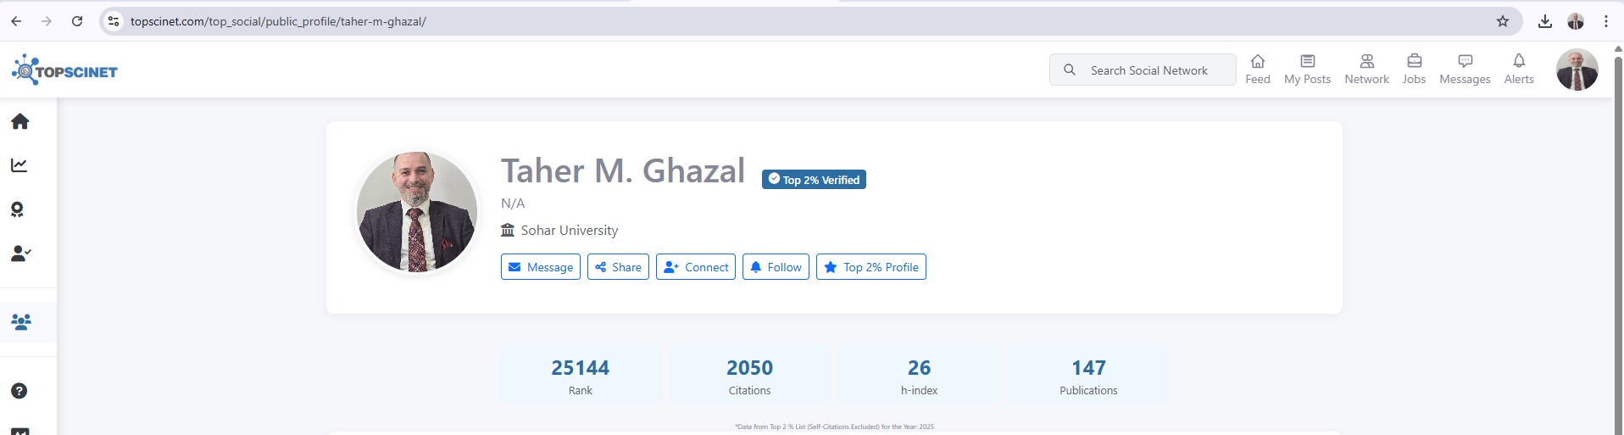
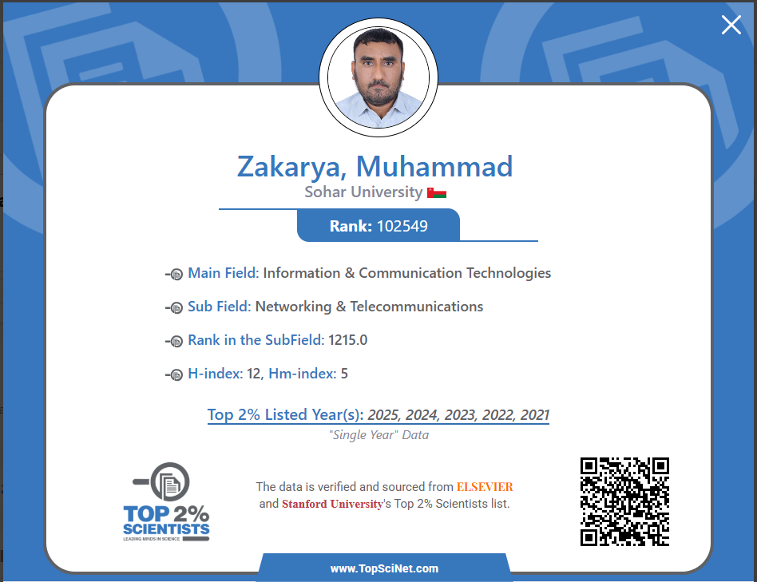
FCIT proudly celebrates the international recognition of its distinguished faculty members for their outstanding research achievements.
Dr. Taher M. Ghazal has attained a global rank of 25,144, placing him among the top 2% of researchers worldwide, in recognition of his exceptional scholarly contributions and significant impact on the global research community.
Dr. Muhammad Zakarya has also earned global distinction with a world rank of 102,549, securing his position among the top 2% of scientists, reflecting his dedication, research excellence, and meaningful contributions in the fields of Information and Communication Technologies and Networking.
FCIT Research and Innovation Activity

The FCIT at Sohar University recently conducted a collaborative workshop with representatives from the University of Queensland, Australia. The session focused on exploring opportunities for joint research collaborations, sharing knowledge on current projects, and discussing possibilities for joint grant applications and research development initiatives.

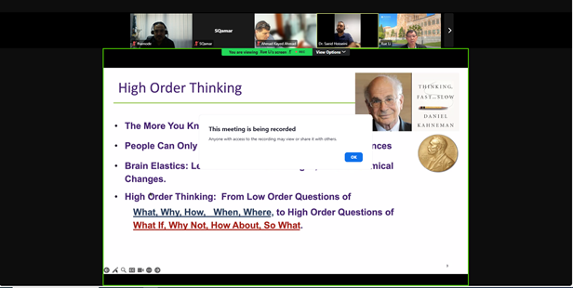
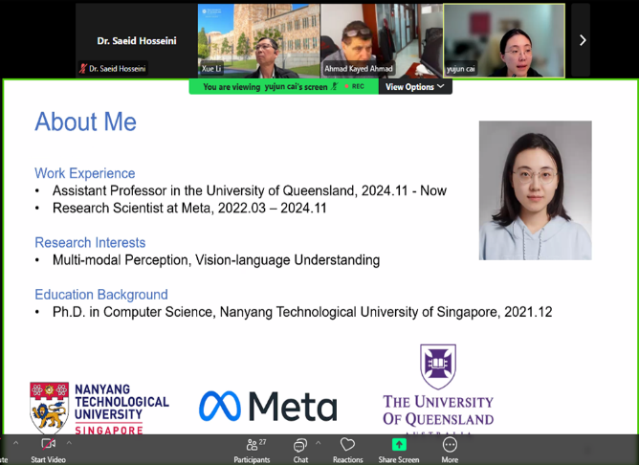
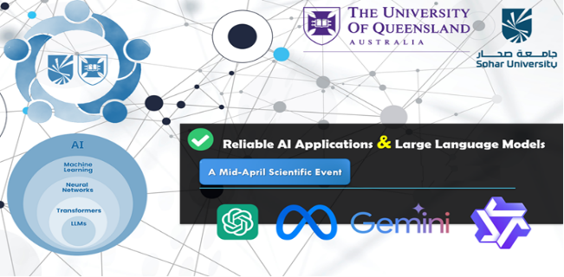
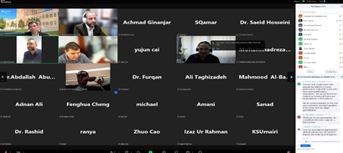

Research Projects

Researchers and students from the Faculty of Computing and Information Technology (FCIT) participated in several research projects showcased during the GCC Police Day Exhibition, organized by the Ministry. The event was attended by numerous officials and researchers. Sohar University representatives delivered outstanding presentations and shared valuable insights during the exhibition.
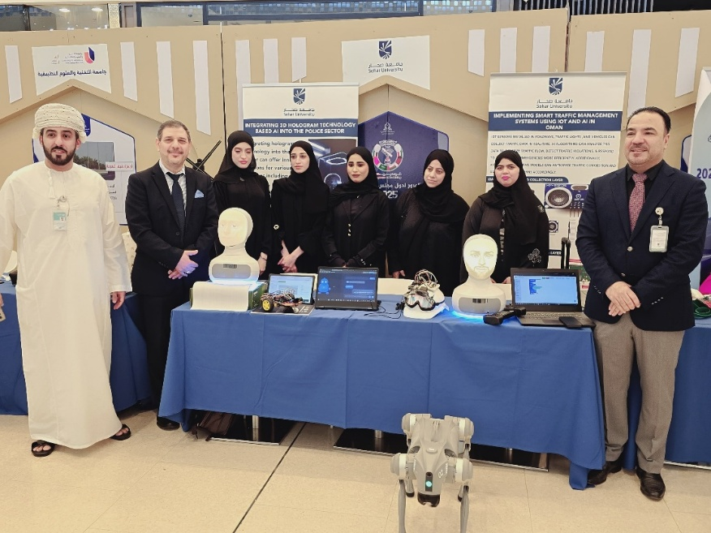

Research
Department of Computer Science & Engineering and IEEE Student Chapter, Chitkara University proudly invite you to an expert talk under the series: A Race Towards Innovative Future in Engineering: An International Expert Talk Series 1.3

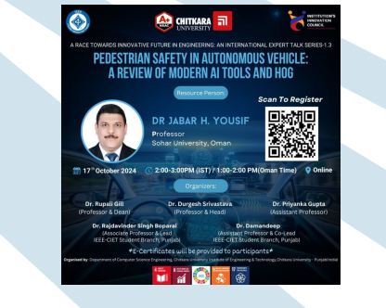

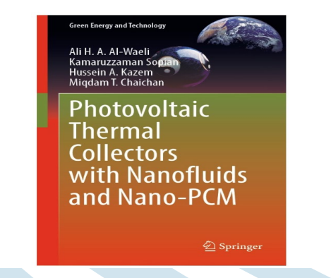
Photovoltaic Thermal Collectors with Nanofluids and Nano-PCM | SpringerLink
- Jabar H. Yousif, Ghassan Al-Kindi, and Durgesh K Srivastava, “Global Software Development for Smart Cities”, 2025. Taylor and Francis Ltd, CRC Press. https://www.routledge.com/5G-Enabled-Technology-for-Smart-City-and-UrbanizationSystem/Hooda-Kiran-Gill-Srivastava-Yousif/p/book/9781032740133
- Jabar H. Yousif, Ghassan Al-Kindi, Ahmad K. Kayed, Durgesh K. Srivastava Book chapter, (2024),” Implementation of Smart Irrigation Systems", 13 September©2024 Wiley Scrivener Publishing LLC. Print ISBN:9781394302956 |Online ISBN:9781394302994, https://doi.org/10.1002/9781394302994.ch12
- Mahmood Al-Bahri, Wasin Al Kishri, “Trends and Challenges in Development of Smart City and Urbanization System”, 2025. Taylor and Francis Ltd, CRC Press.
- Marwan Alshar’e, Abdallah Abualkishik, Khaled Abuhmaidan, Ahmad Kayed “Enhancing Project Security: Unveiling Trust, Interpretability, and Explainability in the Age of AI”, 2025. Taylor and Francis Ltd, CRC Press.
- Abdallah Abualkishik, Marwan Alshar'e, Ahmad Kayed, Khaled Abuhmaidan, Ala Odeibat “Empowering the Future: Digital Twins and Connectivity in Smart City Development”, 2025. Taylor and Francis Ltd, CRC Press

- Workshops and Training
The FCIT members served as keynote speakers at various events, including training sessions and workshops. These engagements provided valuable insights and expertise on key topics, helping to educate attendees and enhance their skills in relevant areas.

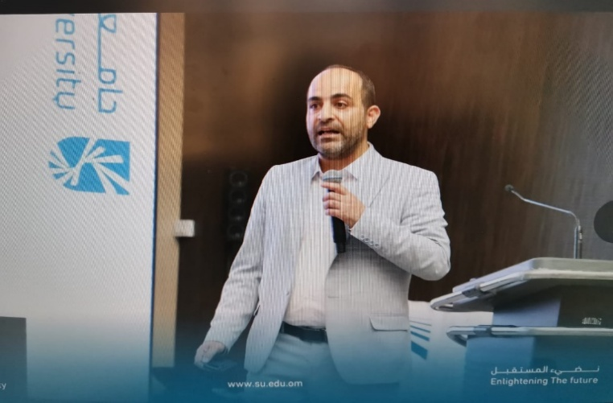
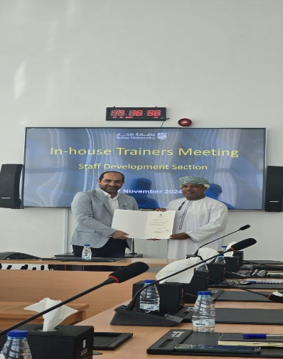

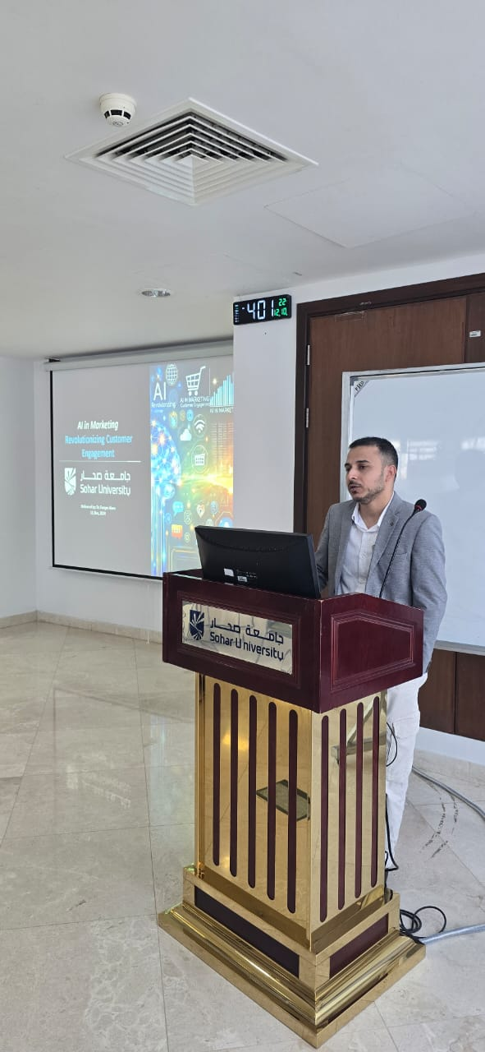
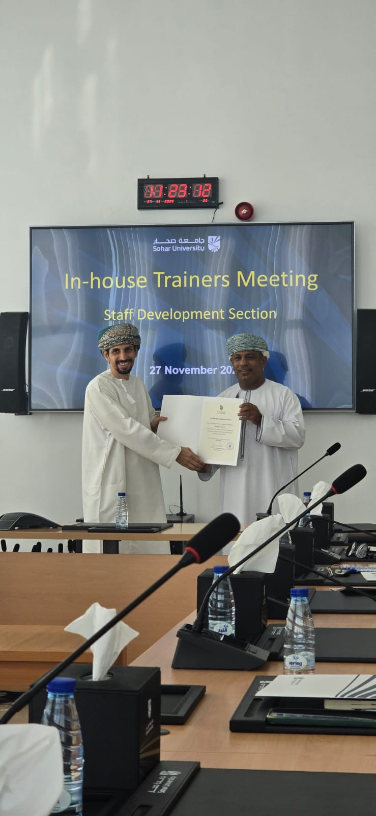

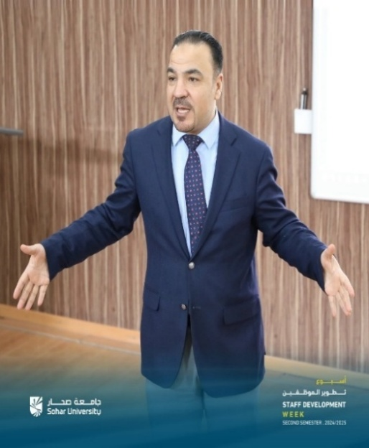
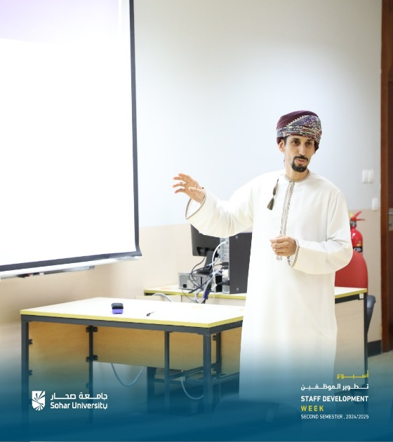

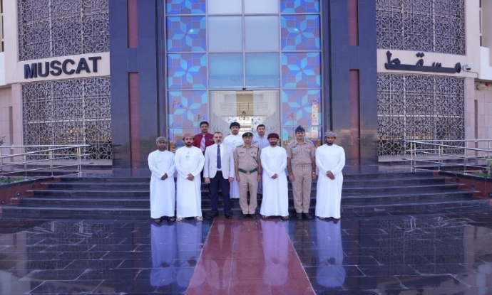

Professor Jabbar Yousef from the Faculty of Computing and IT participated in the Nama Training Camp held at the Innovation Complex at Sultan Qaboos University, as a keynote speaker in a lecture entitled “Innovative Solutions to Enhance Products”. The participants interacted with the lecturer through many questions related to modern technologies that the lecturer addressed to increase production and competition in the labour market

